Govind Ballabh Pant Institute of Engineering &
Technology, Pauri Garhwal

COMPUTER SCIENCE AND APPLICATIONS DEPARTMENT
SOFTWARE REQUIREMENT SPECIFICATION
SESSION 2025-26
ALUMNI HUB – ROLE-BASED NETWORKING
AND REFERRAL PLATFORM
SUBMITTED BY :  NAME: REETU SAINI  INSTITUTE ID : ____________ | SUBMITTED TO:  MR. DEEPAK DANGWAL  ____________

TABLE OF CONTENTS
1. Introduction 3
1.1 Purpose 3
1.2 Scope of the Project 3
1.3 Definitions, Acronyms and Abbreviations 4
1.4 References 4
1.5 Overview of the Document 4
2. Overall Description 6
2.1 Product Perspective 6
2.2 Product Functions 6
2.3 User Classes and Characteristics 7
2.4 Operating Environment 7
2.5 Technology Stack 8
2.6 Design and Implementation Constraints 8
2.7 Assumptions and Dependencies 8
3. System Models 9
3.1 Use Case Diagrams 9
3.2 Data Flow Diagrams (DFD) 11
3.2.1 DFD Level 0 (Context Diagram) 11
3.2.2 DFD Level 1 13
3.3 Flowcharts 14
3.3.1 Registration and Account Approval 14
3.3.2 Sign-in and Role-Based Navigation 15
3.3.3 Hiring Application and Referral 16
3.4 Entity Relationship Diagram (ER Diagram) 17
3.5 Sequence Diagram – Registration and Approval 18
3.6 Data Dictionary 18
3.6.1 users 19
3.6.2 studentProfiles 19
3.6.3 teacherProfiles 19
3.6.4 alumniProfiles 20
3.6.5 posts 20
3.6.6 applications 20
3.6.7 pollVotes 21
3.6.8 chatMessages (global discussion) 21
3.6.9 shortlists and shortlistNotes 21
3.6.10 notifications 21
3.6.11 conversations and messages (private) 22
3.6.12 preapproved (roll list) 22
4. Specific Requirements 23
4.1 Functional Requirements 23
4.1.1 Authentication and Account Approval 23
4.1.2 Student Module 24
4.1.3 Teacher Module 24
4.1.4 Alumni Module 25
4.1.5 Communication 25
4.1.6 Super Admin Module 26
4.1.7 Privacy and Settings 26
4.2 Non-Functional Requirements 27
4.3 Access Control Rules 27
4.4 Business Rules 28
4.5 Test Cases 28
5. External Interface Requirements 30
5.1 User Interfaces 30
5.2 Hardware Interfaces 30
5.3 Software Interfaces 31
5.4 Communication Interfaces 31
6. Current Features 32
7. Future Enhancements 33
8. Project Deployment and Demonstration 34
8.1 Live Application Details 34
8.2 Deployment Process 34
8.3 Demonstration Accounts 34
9. Screenshots 35
10. Conclusion 46

SOFTWARE REQUIREMENTS SPECIFICATION (SRS)
Alumni Hub – Role-Based Networking and Referral Platform

1. Introduction

1.1 Purpose
This Software Requirements Specification (SRS) describes the complete functional and non-functional requirements of Alumni Hub, a role-based networking and referral platform developed as a web application for the students, teachers and alumni of the institute. The document is prepared for college practical submission, follows the structure recommended by IEEE Std 830-1998, and describes the system exactly as it has been implemented and deployed.
The intended readers are the project guide and evaluators, developers who will maintain or extend the system, and the institute administration that will operate it.

1.2 Scope of the Project
Alumni Hub connects three groups that rarely meet in one place: current students looking for guidance and jobs, teachers who publish notices and track students, and alumni who can mentor juniors and refer them to their companies. Every account is verified by a Super Admin before it can be used, so only genuine members of the institute take part.
The system provides:
- A single sign-in and registration page with a Student / Teacher / Alumni role selection, email verification and password reset.
- An approval workflow: new accounts stay pending until the Super Admin approves them; emails on a pre-loaded roll list are approved automatically.
- A live global discussion for all roles and private one-to-one messages.
- A student profile builder that doubles as a resume and exports an ATS-friendly PDF.
- Hiring posts and skill tests published by alumni, applications from students, and an applicant review pipeline (applied → shortlisted / rejected).
- Notices and polls published by teachers, with student and alumni directories, filters and CSV exports.
- Student search, shortlisting, private notes and referral tracking for alumni.
- In-app notifications, profile photos and certificate uploads, data export and account deletion.
All data is stored in Google Firebase (Cloud Firestore), files are stored on Cloudinary, and the application is hosted on Vercel. Access to every record is enforced on the server by Firestore Security Rules.

1.3 Definitions, Acronyms and Abbreviations
Table 1.1: Definitions and acronyms
Term | Description
Alumni Hub | The role-based networking and referral platform described in this document
Super Admin | The administrator account that verifies new users and moderates content
Roll list | A list of pre-approved email addresses maintained by the Super Admin
ATS | Applicant Tracking System – software used by companies to scan resumes
Shortlist | An alumnus's list of students being considered for a referral
Referral | A recommendation of a student by an alumnus to his or her company
SPA | Single-Page Application – a web app that loads once and updates in place
Firebase | Google's cloud platform used for authentication and the database
Firestore | Cloud Firestore – the NoSQL, real-time document database of Firebase
Security Rules | Server-side rules in Firestore that decide who may read or write each document
Cloudinary | Cloud service used to store profile photos and certificate files
Vercel | Cloud hosting platform that builds and serves the web application
DFD | Data Flow Diagram
ERD | Entity Relationship Diagram
CSV | Comma-Separated Values – a spreadsheet-compatible export format
UI | User Interface

1.4 References
- IEEE Std 830-1998, IEEE Recommended Practice for Software Requirements Specifications.
- Project synopsis: Alumni Hub – Role-Based Networking and Referral Platform (MCA).
- Firebase documentation – Authentication, Cloud Firestore and Security Rules (firebase.google.com/docs).
- React documentation (react.dev) and Vercel documentation (vercel.com/docs).
- Digital Personal Data Protection Act, 2023 (India).

1.5 Overview of the Document
Section 2 gives an overall description of the product, its users and its environment. Section 3 presents the system models: architecture, use case diagrams, data flow diagrams, flowcharts, the ER diagram, a sequence diagram and the data dictionary. Section 4 lists the functional and non-functional requirements, access rules and test cases. Section 5 describes the external interfaces. Sections 6 to 10 cover the current features, future enhancements, deployment, screenshots and the conclusion.

2. Overall Description

2.1 Product Perspective
Alumni Hub is a new, self-contained product that follows a client–server (serverless) architecture. The client is a React single-page application that runs in the user's web browser. Instead of a custom application server, the client talks directly to managed cloud services: Firebase Authentication for sign-in, Cloud Firestore for data (protected by Security Rules that act as the server-side business logic) and Cloudinary for files. The built application is hosted on Vercel, which rebuilds and redeploys it automatically whenever new code is pushed to GitHub.
It replaces informal and scattered channels (WhatsApp groups, notice boards, personal emails) with one verified platform where opportunities, guidance and referrals are recorded and traceable.
Users
Student, Teacher,
Alumni, Super Admin
(desktop or mobile
browser)
Vercel – hosting & global CDN
Alumni Hub Web App
React 19 single-page app
React Router · Tailwind CSS
jsPDF (resume export)
Firebase Authentication
email / password,
verification, reset

Cloud Firestore
NoSQL database
+ Security Rules
Cloudinary
profile photos &
certificate files
GitHub repository
source code
HTTPS
sign-in, ID token
read / write,
live listeners
file upload
push → automatic build & deploy
Figure 2.1: System architecture of Alumni Hub

2.2 Product Functions
The major functions of the system, grouped by module, are:
- Authentication & approval – role-based registration, email verification, sign-in, password reset, Super Admin approval and roll-list pre-approval.
- Global discussion – one real-time conversation for all roles with replies and moderation.
- Student module – feed, applications, test submissions, polls, profile builder, ATS resume, alumni directory and application tracking.
- Teacher module – notices and polls, student directory with filters and CSV export, alumni counts by company and export.
- Alumni module – hiring posts and skill tests, applicant review, student search, shortlist, private notes and referrals.
- Super Admin module – approval queue, bulk approval, user management, roll list, announcements and content moderation.
- Communication – private messages and in-app notifications with unread counts.
- Privacy & settings – profile photos, change password, download my data, delete account, Privacy Policy and Terms of Use.

2.3 User Classes and Characteristics
Table 2.1: User classes
User | Description | Main activities
Student | Current student of the institute; moderate computer skills; uses mobile and desktop. | Builds profile and resume, applies to openings, submits tests, votes, talks to alumni.
Teacher | Faculty member of the department. | Publishes notices and polls, reviews and exports student and alumni data.
Alumni | Former student now working in industry; uses the platform occasionally. | Posts openings and tests, reviews applicants, searches, shortlists and refers students.
Super Admin | Single administrator account managed by the department. | Verifies new accounts, maintains the roll list, moderates content, publishes announcements.
Pending user | Newly registered account not yet approved. | Can only see the waiting screen and verify the email address.

2.4 Operating Environment
Table 2.2: Operating environment
Item | Details
Platform | Web application (responsive single-page app)
Hosting | Vercel (global CDN, automatic deployment from GitHub)
Authentication | Firebase Authentication (email and password)
Database | Google Cloud Firestore (NoSQL, real-time) with Security Rules
File storage | Cloudinary (unsigned upload preset)
Browsers | Google Chrome, Microsoft Edge, Mozilla Firefox, Safari (latest versions)
Devices | Desktop, laptop, tablet, Android and iOS phones (screens from 360 px wide)
Network | Internet connection required (HTTPS)

2.5 Technology Stack
Table 2.3: Technology stack
Layer | Technology | Purpose
Front end | React 19, React Router 7 | Single-page application and role-based routing
Styling | Tailwind CSS 3, Inter font, Lucide icons | Responsive, consistent user interface
Build | Create React App (react-scripts 5) | Bundling and production build
Authentication | Firebase Authentication (JS SDK 12) | Sign-in, verification email, password reset
Database | Cloud Firestore (JS SDK 12) | Documents, real-time listeners, Security Rules
Files | Cloudinary Upload API | Profile photos and certificate files
PDF | jsPDF 4 | ATS-friendly resume export
Hosting / CI | Vercel, GitHub | Automatic build and deployment
Testing | Firebase Emulator Suite, Puppeteer | Security-rule tests and end-to-end browser tests

2.6 Design and Implementation Constraints
- The system must run entirely on free tiers (Firebase Spark plan, Vercel Hobby, Cloudinary Free).
- There is no custom back-end server; all authorisation must be expressed in Firestore Security Rules.
- An Internet connection is required; the application depends on Firebase, Cloudinary and Vercel being available.
- The Super Admin is identified by a fixed login email (superadmin@gmail.com).
- Files are limited to 5 MB for images and 10 MB for certificates; chat messages to 1,000 characters and private messages to 2,000 characters.

2.7 Assumptions and Dependencies
- Users have a valid email address and basic computer or smartphone knowledge.
- The department provides the Super Admin with an up-to-date roll list or verifies accounts manually.
- Firebase, Cloudinary and Vercel services remain available within their free limits.
- Alumni share opportunities in a personal capacity; the institute does not guarantee jobs or referrals.

3. System Models

3.1 Use Case Diagrams
Figure 3.1 shows the use cases common to every member. Figure 3.2 shows the use cases specific to each role.
Alumni Hub
Member
(Student, Teacher,
Alumni or Super Admin)
Register / sign in
Verify email · reset password
Manage own profile & photo
Read feed · vote in polls
Global discussion
Direct messages
View notifications
Settings: password, export data,
delete account
Figure 3.1: Use cases common to all members
Alumni Hub
Student
Apply to hiring post
Submit test solution
Export ATS resume
Find & message alumni
Track applications
Teacher
Publish notice / poll
View & export students
Alumni counts & export
Alumni
Publish hiring post / test
Review applicants
Search students
Shortlist & refer
Keep private notes
Super Admin
Approve / reject accounts
Suspend / reactivate
Manage roll list
Moderate content
Publish announcements
Figure 3.2: Role-specific use cases
Table 3.1: Main use cases
ID | Use case | Actor | Description
UC-01 | Register | Student, Teacher, Alumni | Create an account with a role; account waits for approval unless the email is on the roll list.
UC-02 | Approve account | Super Admin | Check registration details and email verification; approve, reject with a reason, or bulk-approve.
UC-03 | Build profile & resume | Student | Fill in skills, tools, experience, education, certifications and links; export an ATS-friendly PDF.
UC-04 | Publish hiring post / test | Alumni | Post an opening (company, role, location, deadline) or a skill test (skills, due date, link).
UC-05 | Apply / submit solution | Student | Apply once to an opening, or submit a solution link for a test.
UC-06 | Review applicants | Alumni | Open applicant profiles and set status to Shortlisted or Rejected.
UC-07 | Shortlist & refer | Alumni | Search students, shortlist them, keep private notes and mark them as referred.
UC-08 | Publish notice / poll | Teacher, Super Admin | Publish a notice or a poll with two to six options.
UC-09 | Export directories | Teacher | Filter students and alumni and download CSV files, including alumni counts per company.
UC-10 | Discuss & message | All members | Use the global discussion and private one-to-one messages.
UC-11 | Manage roll list | Super Admin | Add or remove pre-approved emails by pasting or uploading a CSV file.
UC-12 | Moderate content | Super Admin | Delete any post or discussion message; suspend or reactivate accounts.

3.2 Data Flow Diagrams (DFD)

3.2.1 DFD Level 0 (Context Diagram)
The context diagram shows Alumni Hub as a single process and the external entities that exchange data with it.
0
Alumni Hub
System
Student
Teacher
Alumni
Super Admin
Cloudinary
(file storage)
registration, profile,
applications, messages
feed, notifications,
resume PDF
notices, polls,
filters
student & alumni lists,
CSV exports
hiring posts, tests,
shortlists, referrals
applicants,
student profiles
approvals, roll list,
moderation
pending accounts,
statistics
photos, files
Figure 3.3: DFD Level 0 – context diagram

3.2.2 DFD Level 1
Users
Student / Teacher /
Alumni
1.0
Authentication
& Approval
2.0
Profile
Management
3.0
Posts &
Applications
4.0
Discussion &
Messaging
5.0
Search,
Shortlist
& Referral
D1 Users
D2 Roll List
D3 Profiles
D4 Posts & Votes
D5 Applications
D6 Chat & Messages
D7 Shortlists & Notes
D8 Notifications
7.0
Admin-
istration
6.0
Notifi-
cations
D3 Profiles
Super Admin
register, sign in
session, status
profile data / resume
posts, applications,
votes / feed
messages
filters, shortlist /
matching students
account
check email
profile
posts, votes
applications
messages
student
profiles
shortlists
approve, moderate
pending list, stats
account status
roll list
delete posts
delete
messages
status changes
shortlist, referral
save / read
notifications
Figure 3.4: DFD Level 1 – main processes and data stores

3.3 Flowcharts

3.3.1 Registration and Account Approval
Start
Open Alumni Hub
Choose role and enter name, email, password
(+ department / company / batch)
Details valid and
terms accepted?
Create Firebase login,
send verification email
Email on the
roll list?
Status = Approved
(automatic)
Status = Pending,
Super Admin notified
Admin
approves?
Status = Rejected,
reason shown to user
End
Status = Approved,
user notified
Open role dashboard
Yes
No
Yes
No
No
Yes
Figure 3.5: Registration and approval flowchart

3.3.2 Sign-in and Role-Based Navigation
Start
Open sign-in page
Enter email and password
Credentials
valid?
Show error /
“Forgot password?”
Account
approved?
Waiting / rejected /
suspended screen
Role?
Student
dashboard
Feed · apply · vote
Profile & resume PDF
Find alumni
Applications
Teacher
dashboard
Notices & polls
Student profiles
Alumni counts
CSV exports
Alumni
dashboard
Hiring posts & tests
Review applicants
Search students
Shortlist & refer
Super Admin
overview
Approve accounts
Roll list · users
Moderate content
Announcements
Messages · Notifications · Discussion · Settings (all roles)
Sign out / End
No
Yes
No
Yes
Figure 3.6: Sign-in and role-based navigation flowchart

3.3.3 Hiring Application and Referral
Start
Alumnus publishes a hiring post
Post appears live in every
student's feed
Deadline
passed?
“Applications closed”
Student clicks “Apply now”
(application status = Applied)
Alumnus notified; opens the
student's profile and resume
Suitable
candidate?
Status = Rejected,
student notified
Status = Shortlisted,
student notified
Alumnus adds student to Shortlist
(private note)
Referral submitted at the company;
marked “Referred”, student notified
End
Yes
No
No
Yes
Figure 3.7: Hiring application and referral flowchart

3.4 Entity Relationship Diagram (ER Diagram)
POLL_VOTE
voteId (PK)
postId (FK)
uid (FK)
selectedOption
votedAt
TEACHER_PROFILE
uid (PK, FK)
name
department
designation
photoURL
STUDENT_PROFILE
uid (PK, FK)
designation, summary
phone, location
photoURL
skills[ ], tools[ ]
languages[ ]
experience[ ]
education[ ]
certifications[ ]
links{ }
ALUMNI_PROFILE
uid (PK, FK)
company, jobRole
domain
experienceYears
location, batch
linkedin, bio
photoURL
PREAPPROVED
email (PK)
role
name
addedBy, addedAt
APPLICATION
applicationId (PK)
postId (FK)
studentUid (FK)
postAuthorUid (FK)
status
submissionLink
appliedAt
POST
postId (PK)
authorUid (FK)
authorRole
type
title, body
options[ ], meta{ }
createdAt
USER
uid (PK)
name, email
role
status
photoURL
emailVerified
reviewNote, reviewedBy
createdAt
CONVERSATION
id (PK)
participants[2] (FK)
lastMessage
lastSenderUid
readAt{ }, updatedAt
DIRECT_MESSAGE
id (PK)
conversationId (FK)
senderUid (FK)
text
sentAt
CHAT_MESSAGE
id (PK)
senderUid (FK)
senderRole
text
replyTo (FK)
sentAt
NOTIFICATION
id (PK)
toUid (FK)
fromUid (FK)
type, title, body
link, read
createdAt
SHORTLIST
id (PK)
alumniUid (FK)
studentUid (FK)
status
createdAt
SHORTLIST_NOTE
id (PK, FK)
note
updatedAt
has (1 : 1)
has (1 : 1)
has (1 : 1)
pre-approves (1 : 0..1)
creates
1 : N
receives
1 : N
submits (1 : N)
has (1 : N)
casts (1 : N)
participates
M : N
contains
1 : N
sends (1 : N)
receives (1 : N)
shortlists / is shortlisted (1 : N)
has
1 : 0..1
replies to
(0..1)
Figure 3.8: Entity relationship diagram

3.5 Sequence Diagram – Registration and Approval
Student
React App
Firebase Auth
Firestore
Super Admin
1. fill sign-up form
2. createUser(email, password)
3. uid + ID token
4. get preapproved/{email}
5. set users/{uid} status = pending
6. set profile + admin notification
7. verification email
8. “Waiting for approval” screen
9. approve: status = approved
10. live update (onSnapshot)
11. open role dashboard
12. “account approved” notification
Figure 3.9: Sequence diagram for registration and approval

3.6 Data Dictionary
Cloud Firestore stores data as documents grouped into collections. PK = document identifier, FK = reference to another document.

3.6.1 users
Table 3.2: users collection
Field | Type | Description
uid (PK) | string | Firebase Authentication user id
name | string | Full name (1–80 characters)
email | string | Login email (must match the signed-in account)
role | string | student | teacher | alumni | admin (cannot be changed by the user)
status | string | pending | approved | rejected | suspended
photoURL | string | Profile photo URL (https)
emailVerified | boolean | True once the email link has been clicked
reviewNote, reviewedBy, reviewedAt | string / timestamp | Reason and details of the last admin review
createdAt | timestamp | Registration time

3.6.2 studentProfiles
Table 3.3: studentProfiles collection
Field | Type | Description
uid (PK, FK) | string | Same id as users
designation, summary | string | Headline and professional summary (max 1,200 characters)
phone, location, photoURL | string | Contact details and photo
skills, tools, languages | array | Lists of strings used by search filters
experience | array | { title, organization, mode (onsite / virtual), startDate, endDate, description }
education | array | { degree, institution, year, score }
certifications | array | { name, issuer, year, url (link or uploaded file) }
links | map | { linkedin, github, portfolio, other }
updatedAt | timestamp | Last saved

3.6.3 teacherProfiles
Table 3.4: teacherProfiles collection
Field | Type | Description
uid (PK, FK) | string | Same id as users
name, email | string | Copied from the account
department, designation | string | Entered at registration, editable later
photoURL | string | Profile photo

3.6.4 alumniProfiles
Table 3.5: alumniProfiles collection
Field | Type | Description
uid (PK, FK) | string | Same id as users
company, jobRole, domain | string | Current employment
experienceYears | string | Years of experience
location, batch | string | City and graduation batch
linkedin, bio, photoURL | string | Public details shown in the alumni directory

3.6.5 posts
Table 3.6: posts collection
Field | Type | Description
postId (PK) | string | Document id
authorUid (FK), authorName, authorRole | string | Author (name and role are checked against the users record)
type | string | notice | poll (teacher, admin) or hiring | test (alumni)
title, body | string | Content
options | array | Poll options (2–6)
meta | map | Hiring: company, jobRole, location, deadline, link. Test: skills, deadline, link
createdAt | timestamp | Publish time

3.6.6 applications
Table 3.7: applications collection
Field | Type | Description
applicationId (PK) | string | postId_studentUid (one application per post)
postId (FK), postTitle, postType, company | string | The post applied to
postAuthorUid (FK) | string | Alumnus who reviews the application
studentUid (FK), studentName, studentEmail | string | Applicant
status | string | applied | shortlisted | rejected
submissionLink | string | Solution link for skill tests
appliedAt, updatedAt | timestamp | Times

3.6.7 pollVotes
Table 3.8: pollVotes collection
Field | Type | Description
voteId (PK) | string | postId_uid (one vote per person)
postId (FK), uid (FK) | string | Poll and voter
selectedOption | string | Must be one of the poll's options

3.6.8 chatMessages (global discussion)
Table 3.9: chatMessages (global discussion) collection
Field | Type | Description
id (PK) | string | Document id
senderUid (FK), senderName, senderRole | string | Sender (checked against the users record)
text | string | 1–1,000 characters
replyTo (FK) | string / null | Id of the message being replied to
sentAt | timestamp | Time sent

3.6.9 shortlists and shortlistNotes
Table 3.10: shortlists and shortlistNotes collection
Field | Type | Description
id (PK) | string | alumniUid_studentUid
alumniUid (FK), studentUid (FK) | string | Alumnus and student
status | string | shortlisted | referred
note (shortlistNotes) | string | Private note readable only by the alumnus

3.6.10 notifications
Table 3.11: notifications collection
Field | Type | Description
id (PK) | string | Document id
toUid (FK) | string | Recipient, or "admin" for the Super Admin
fromUid (FK), fromName | string | Sender
type | string | account | application | application_status | shortlist | referral | reply | registration
title, body, link | string | Text and the page it opens
read | boolean | Read state

3.6.11 conversations and messages (private)
Table 3.12: conversations and messages (private) collection
Field | Type | Description
id (PK) | string | smallerUid_largerUid
participants (FK) | array | Exactly two user ids
names, roles, photos | map | Display details per participant
lastMessage, lastSenderUid, updatedAt | string / timestamp | Conversation preview
readAt | map | Last time each participant opened the conversation
messages/{id}: senderUid, text, sentAt | sub-collection | Messages of 1–2,000 characters

3.6.12 preapproved (roll list)
Table 3.13: preapproved (roll list) collection
Field | Type | Description
email (PK) | string | Lower-case email address
role | string | student | teacher | alumni
name, addedBy, addedAt | string / timestamp | Optional name and audit details

4. Specific Requirements

4.1 Functional Requirements

4.1.1 Authentication and Account Approval
Table 4.1: Authentication and approval requirements
ID | Requirement
FR-1.1 | The system shall allow a user to register with full name, email, password (minimum 6 characters) and a role: Student, Teacher or Alumni.
FR-1.2 | The system shall ask teachers for department and designation, and alumni for company, job role and graduation batch, at registration.
FR-1.3 | The system shall require acceptance of the Terms of Use and Privacy Policy before registration.
FR-1.4 | The system shall create every new account with status Pending unless its email and role are on the roll list, in which case it shall be Approved immediately.
FR-1.5 | The system shall send an email-verification link at registration and allow the user to resend it and confirm verification.
FR-1.6 | The system shall show pending, rejected and suspended users a status screen (with the admin's reason, if any) and deny them access to all other data.
FR-1.7 | The system shall switch a waiting user to the dashboard automatically, without reloading, as soon as the account is approved.
FR-1.8 | The system shall sign users in with email and password and route each role to its own dashboard.
FR-1.9 | The system shall send a password-reset email and show the same neutral message whether or not the email is registered.
FR-1.10 | The system shall prevent users from changing their own role, status or email.

4.1.2 Student Module
Table 4.2: Student requirements
ID | Requirement
FR-2.1 | The system shall show a live feed of hiring posts, skill tests, notices and polls, filterable by type, with “load older posts”.
FR-2.2 | The system shall let a student apply once to a hiring post and shall disable applying after the deadline.
FR-2.3 | The system shall let a student submit a solution link for a skill test.
FR-2.4 | The system shall let a student vote once in a poll and show results after voting.
FR-2.5 | The system shall provide a profile builder with headline, summary, phone, location, skills, tools, languages, experience (onsite / virtual internship), education, certifications and links, and show a profile-strength percentage.
FR-2.6 | The system shall export the profile as an ATS-friendly PDF resume with selectable text in reading order.
FR-2.7 | The system shall let a student upload a profile photo and certificate files (PDF or image).
FR-2.8 | The system shall provide an alumni directory searchable by name, company, role and batch, with profile pages and a Message button.
FR-2.9 | The system shall list the student's applications with status, allow withdrawing while Applied, and show alumni who shortlisted or referred the student.

4.1.3 Teacher Module
Table 4.3: Teacher requirements
ID | Requirement
FR-3.1 | The system shall show counters for approved students, approved alumni and the teacher's posts.
FR-3.2 | The system shall let a teacher publish notices and polls with two to six options.
FR-3.3 | The system shall list all approved students with search, skill and tool chips (match all selected), location, internship-experience filter and sorting.
FR-3.4 | The system shall export the filtered student list as CSV.
FR-3.5 | The system shall show alumni with counts per company and batch, and export the alumni list and the company counts as CSV.
FR-3.6 | The system shall let a teacher edit name, department, designation and photo.

4.1.4 Alumni Module
Table 4.4: Alumni requirements
ID | Requirement
FR-4.1 | The system shall let an alumnus publish hiring posts (company, role, location, deadline, link) and skill tests (skills, due date, link).
FR-4.2 | The system shall list applicants under each post and let the author set the status to Applied, Shortlisted or Rejected.
FR-4.3 | The system shall let an alumnus search students with the same filters as teachers and open full profiles and resumes.
FR-4.4 | The system shall let an alumnus shortlist students, keep private notes, mark them as Referred and remove them.
FR-4.5 | The system shall let an alumnus edit company, role, domain, experience, location, batch, LinkedIn, bio and photo.
FR-4.6 | The system shall let authors delete their own posts.

4.1.5 Communication
Table 4.5: Communication requirements
ID | Requirement
FR-5.1 | The system shall provide one real-time discussion for all approved members, with role badges, replies, deletion of one's own messages and “load earlier messages”.
FR-5.2 | The system shall provide private one-to-one conversations between approved members, readable only by the two participants, with unread indicators.
FR-5.3 | The system shall notify users in the app when their account is reviewed, when someone applies to their post, when their application status changes, when they are shortlisted or referred, and when someone replies to them.
FR-5.4 | The system shall notify the Super Admin of every new registration and show new posts since the user's last visit.
FR-5.5 | The system shall show unread counts in the navigation and the browser tab title, and allow marking notifications as read or deleting them.

4.1.6 Super Admin Module
Table 4.6: Super Admin requirements
ID | Requirement
FR-6.1 | The system shall show the Super Admin counts of pending accounts, students, teachers, alumni, posts and messages.
FR-6.2 | The system shall list pending accounts with their registration details and email-verification status, and allow approve, reject with a reason, and bulk approve.
FR-6.3 | The system shall list all users with search, role and status filters, details, suspend / reactivate actions and CSV export.
FR-6.4 | The system shall let the Super Admin add roll-list emails by pasting or uploading a CSV (email, role, name), approve matching waiting accounts automatically, and remove entries.
FR-6.5 | The system shall let the Super Admin publish announcements (notices and polls) and delete any post or discussion message.
FR-6.6 | The system shall not allow the Super Admin to change user roles or read private messages and alumni notes.

4.1.7 Privacy and Settings
Table 4.7: Privacy and settings requirements
ID | Requirement
FR-7.1 | The system shall let users change their password after confirming the current one.
FR-7.2 | The system shall let users download a copy of their data as a JSON file.
FR-7.3 | The system shall let users permanently delete their account and everything they created, after confirming their password.
FR-7.4 | The system shall provide public Privacy Policy and Terms of Use pages.

4.2 Non-Functional Requirements
Table 4.8: Non-functional requirements
Category | Requirement
Performance | Pages shall load within 3 seconds on a normal 4G connection; new posts and messages shall appear for other users within about 1 second through real-time listeners. Long lists are paged (25 posts, 100 messages at a time).
Security | All traffic uses HTTPS. Every read and write is checked by Firestore Security Rules on the server: role, approval status, ownership, field-level changes and value limits. Passwords are handled only by Firebase Authentication.
Reliability | Data integrity is enforced by deterministic document ids (one application, vote and shortlist per pair) and rule validation; failed registrations are rolled back.
Availability | 24 × 7 access through Vercel's CDN and Google Cloud infrastructure.
Usability | Simple, consistent interface with short labels, clear empty states and confirmation for destructive actions.
Responsiveness | Works from 360 px phone screens to large desktops; phones get a bottom tab bar and no horizontal scrolling.
Accessibility | Readable font sizes, sufficient contrast, labelled form fields and icon buttons, keyboard-usable dialogs.
Privacy | Only approved members can see profiles; private messages and notes are visible only to their owners; users can export and delete their data (DPDP Act 2023).
Maintainability | Modular React components, a single data-service layer and documented security rules in version control.
Scalability | Serverless back end scales automatically within Firebase quotas.
Portability | Runs in any modern browser on Windows, macOS, Linux, Android and iOS without installation.

4.3 Access Control Rules
Table 4.9 summarises what each kind of user may do. All of these rules are enforced on the server by Firestore Security Rules, not only in the user interface.
Table 4.9: Access control matrix
Action | Pending | Student | Teacher | Alumni | Super Admin
Read feed, profiles, discussion | No | Yes | Yes | Yes | Yes
Edit own profile | Yes | Yes | Yes | Yes | –
Publish notice / poll | No | No | Yes | No | Yes
Publish hiring post / test | No | No | No | Yes | No
Apply / submit solution | No | Yes | No | No | No
Change application status | No | No | No | Own posts | No
Shortlist and private notes | No | No | No | Own | No
Private messages | No | Own | Own | Own | Own
Delete posts / messages | No | Own | Own | Own | Any
Approve / suspend accounts | No | No | No | No | Yes
Manage roll list | No | No | No | No | Yes
Change any user's role | No | No | No | No | No

4.4 Business Rules
- A student can apply to a post only once; the application id is postId_studentUid.
- A person can vote in a poll only once, and only for one of the poll's options.
- Applications are accepted only for hiring posts and skill tests, never for notices or polls.
- Names on posts, messages and applications must match the author's account name.
- Accounts created before the approval system existed are treated as approved.
- Deleting an account also deletes the person's profile, posts, discussion messages, applications, votes, shortlists and conversations.

4.5 Test Cases
The system was tested with automated end-to-end browser tests (Puppeteer) and security-rule tests against the Firebase Emulator Suite. Table 4.10 lists representative test cases.
Table 4.10: Test cases
ID | Test case | Expected result | Result
TC-01 | Open a protected page while signed out | Redirected to the sign-in page | Pass
TC-02 | Sign in with a wrong password | “Incorrect email or password” shown | Pass
TC-03 | Register without accepting the terms | Error asking to accept the terms | Pass
TC-04 | Register a new student | Waiting-for-approval screen; no data visible | Pass
TC-05 | Admin approves the account | User is moved to the dashboard live | Pass
TC-06 | Admin rejects with a reason | User sees “not approved” and the reason | Pass
TC-07 | Register with an email on the roll list | Account approved immediately | Pass
TC-08 | Admin suspends an account | User is locked out immediately | Pass
TC-09 | Request a password reset | Reset email sent, neutral message shown | Pass
TC-10 | Click the verification link | Admin queue shows “Verified email” | Pass
TC-11 | Teacher publishes a notice | Appears in the student feed in real time | Pass
TC-12 | Create a poll with one option | Rejected; poll needs two or more options | Pass
TC-13 | Hiring post with a past deadline | “Applications closed”; Apply disabled | Pass
TC-14 | Student applies to a hiring post | Alumnus notified; second application blocked | Pass
TC-15 | Alumnus shortlists an applicant | Student sees status and a notification | Pass
TC-16 | Save profile and reload | All data persists; strength percentage rises | Pass
TC-17 | Export ATS resume | Valid PDF with text in reading order | Pass
TC-18 | Teacher filters students and exports CSV | CSV contains exactly the filtered rows | Pass
TC-19 | Alumni counts by company export | CSV totals match the directory | Pass
TC-20 | Alumnus marks a student as referred | Student sees “referred you” | Pass
TC-21 | Send a private message | Receiver sees unread badge; third person denied | Pass
TC-22 | Reply in the discussion | Original author is notified | Pass
TC-23 | Upload a profile photo | Photo appears in the sidebar and lists | Pass
TC-24 | Change password | Sign-in works with the new password | Pass
TC-25 | Download my data | JSON file downloaded | Pass
TC-26 | Delete account | Login and all personal data removed | Pass
TC-27 | Student opens a teacher URL | Redirected to the student dashboard | Pass
TC-28 | Student tries to change own role (direct database call) | Denied by Security Rules | Pass
TC-29 | Phone screen 390 px wide | No horizontal scroll; tab bar works | Pass
Summary: 142 automated browser checks and 134 security-rule checks passed; the production build compiles with no warnings.

5. External Interface Requirements

5.1 User Interfaces
The interface is responsive. On desktop a sidebar lists the pages; on phones a bottom tab bar holds the main pages and a menu holds the rest. Table 5.1 lists the screens.
Table 5.1: Screens of the application
Screen (route) | Users | Purpose
Sign in / Register (/auth) | Everyone | Sign in, create an account, reset password
Privacy Policy, Terms (/privacy, /terms) | Everyone | Legal information
Student dashboard (/student) | Student | Statistics, profile progress, feed
Profile & Resume (/student/profile) | Student | Profile builder, photo, certificates, resume PDF
Find Alumni (/student/alumni) | Student | Alumni directory
Applications (/student/applications) | Student | Application status and alumni interest
Teacher dashboard (/teacher) | Teacher | Counters, notices and polls, feed
Students (/teacher/students) | Teacher | Student directory with filters and CSV export
Alumni (/teacher/alumni) | Teacher | Alumni counts per company and CSV exports
Alumni dashboard (/alumni) | Alumni | Posts, applicants and statistics
Search Students (/alumni/search) | Alumni | Filters and shortlisting
Shortlist (/alumni/shortlist) | Alumni | Shortlisted and referred students, private notes
Overview, Users, Roll List, Content (/admin…) | Super Admin | Approvals, user management, roll list, moderation
Discussion, Messages, Notifications, Settings | All approved users | Communication and account settings
Student / member profile (/students/:id, /profile/:id) | All approved users | Read-only public profiles

5.2 Hardware Interfaces
- Any desktop, laptop, tablet or smartphone with a modern web browser.
- No special hardware is required; a camera or file system is used only to choose photos and certificate files.

5.3 Software Interfaces
Table 5.2: Software interfaces
Interface | Used for | Protocol / format
Firebase Authentication | Accounts, sign-in, verification and reset emails | Firebase JS SDK over HTTPS
Cloud Firestore | All application data and real-time updates | Firebase JS SDK (gRPC / WebChannel over HTTPS)
Firestore Security Rules | Server-side authorisation and validation | Rules language, deployed with Firebase CLI
Cloudinary Upload API | Profile photos and certificate files | HTTPS POST (multipart), unsigned preset
jsPDF | Generating the resume PDF in the browser | JavaScript library
Vercel | Hosting, build and deployment from GitHub | HTTPS, Git

5.4 Communication Interfaces
- All communication uses HTTPS (TLS).
- Real-time updates use Firestore listeners (persistent HTTPS streams).
- Emails (verification and password reset) are sent by Firebase Authentication.

6. Current Features
- Role-based registration with Super Admin approval, roll-list pre-approval and bulk approval.
- Email verification, password reset, change password and secure sign-out.
- Real-time global discussion and private one-to-one messages with unread badges.
- In-app notifications for account reviews, applications, shortlists, referrals, replies and new posts.
- Student profile builder with profile strength, photo and certificate uploads, and one-click ATS-friendly PDF resume.
- Hiring posts, skill tests with solution links, notices and polls with live results.
- Applicant review pipeline and alumni shortlist with private notes and referral tracking.
- Student and alumni directories with filters, alumni counts per company, and CSV exports.
- Super Admin console: statistics, user management, roll list, announcements and moderation.
- Privacy features: Privacy Policy, Terms of Use, download my data and delete account.
- Responsive design with a phone tab bar; server-side security rules for every action.

7. Future Enhancements
- Email alerts for approvals, applications and referrals.
- Installable Progressive Web App (PWA) with offline reading and push notifications.
- Events and webinars calendar with registrations and reminders.
- Mentorship sessions that students can book with alumni.
- Skill-based matching that recommends students for each opening.
- Placement analytics dashboard for the department.
- Native Android application.
- Support for multiple departments and institutes.

8. Project Deployment and Demonstration

8.1 Live Application Details
Alumni Hub is fully implemented and deployed as a live, working application.
- Live URL: https://alumnihubgbpiet.vercel.app/
- Hosting platform: Vercel (cloud hosting and CDN, automatic deployment from GitHub)
- Backend services: Firebase Authentication and Cloud Firestore (with Security Rules)
- File storage: Cloudinary
- Source code: GitHub repository ReetuS21/Alumni
- Application type: Responsive web application for desktop and mobile browsers

8.2 Deployment Process
- Code is pushed to the main branch of the GitHub repository.
- Vercel automatically installs dependencies, builds the React application and publishes it to its CDN.
- Firestore Security Rules and indexes are deployed with the Firebase CLI (firebase deploy --only firestore).
- Environment variables (Firebase and Cloudinary keys) are stored in the Vercel project settings, not in the code.
- The Super Admin account is created once with the setup script (npm run seed).

8.3 Demonstration Accounts
For demonstration, one approved account exists for each role (student, teacher and alumni) together with the Super Admin account. Their credentials are shared with the evaluators separately and are not shown anywhere in the application.

9. Screenshots
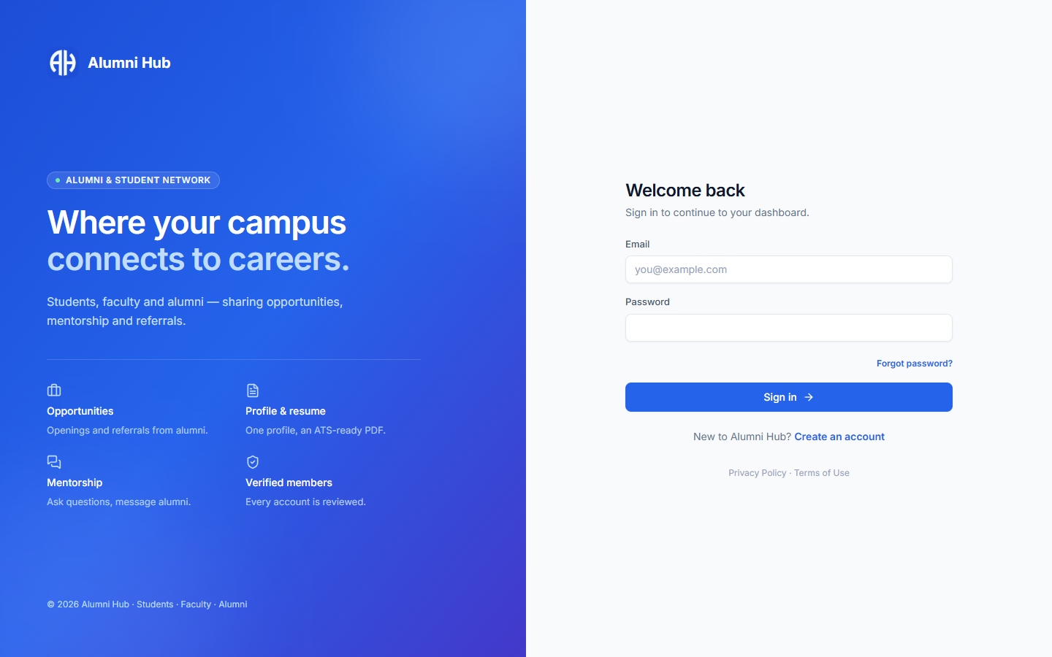
Figure 9.1: Sign-in page
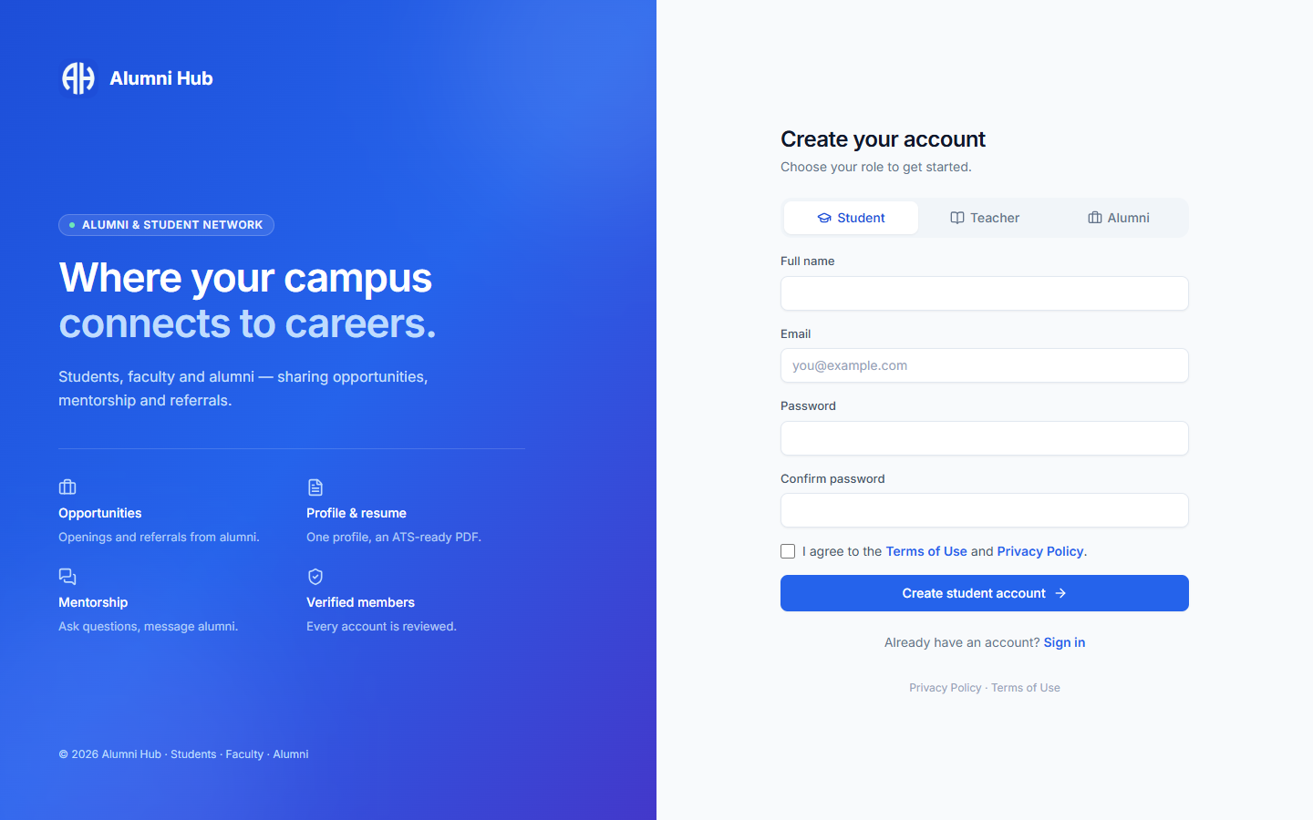
Figure 9.2: Registration with role selection
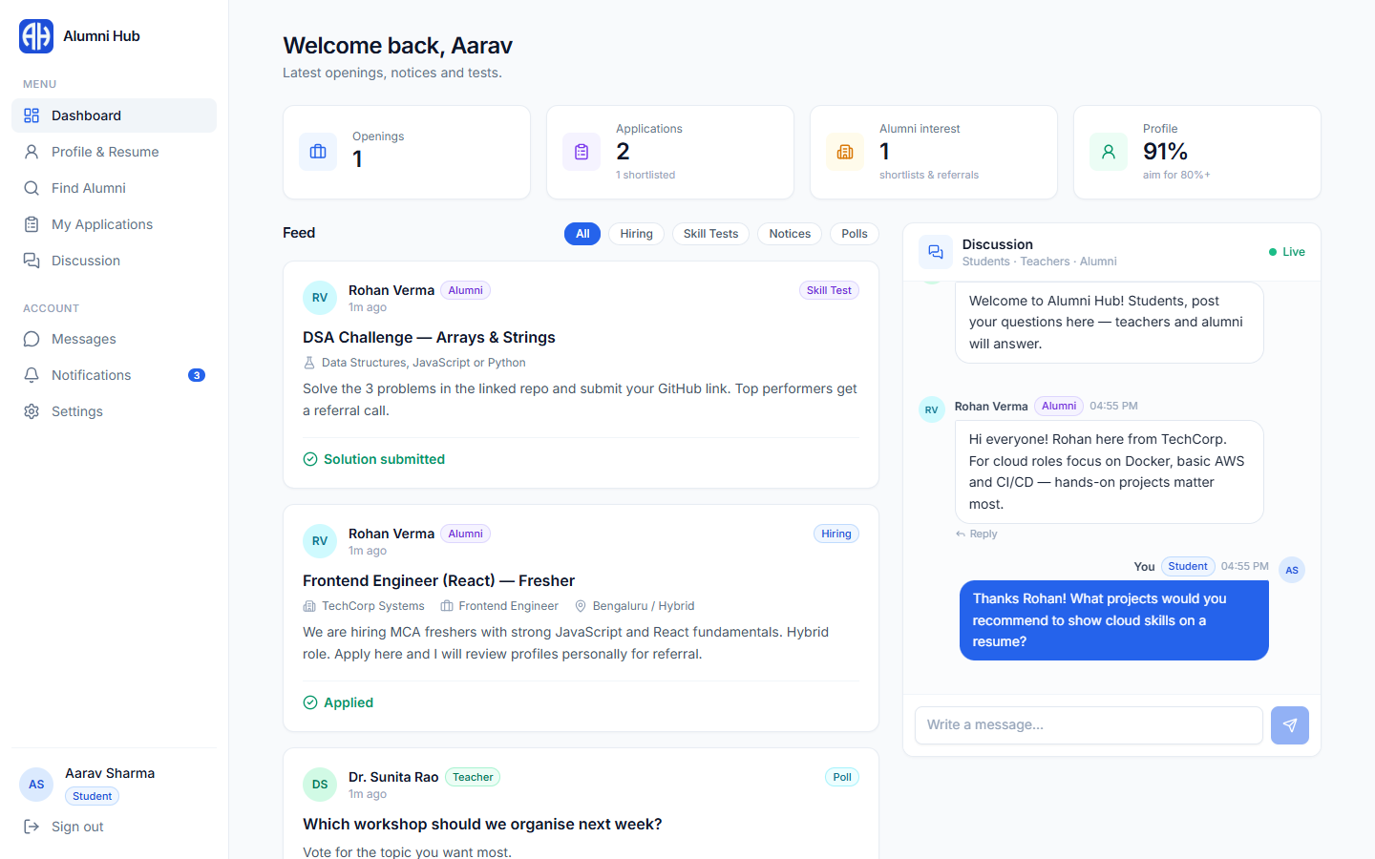
Figure 9.3: Student dashboard with live feed and discussion
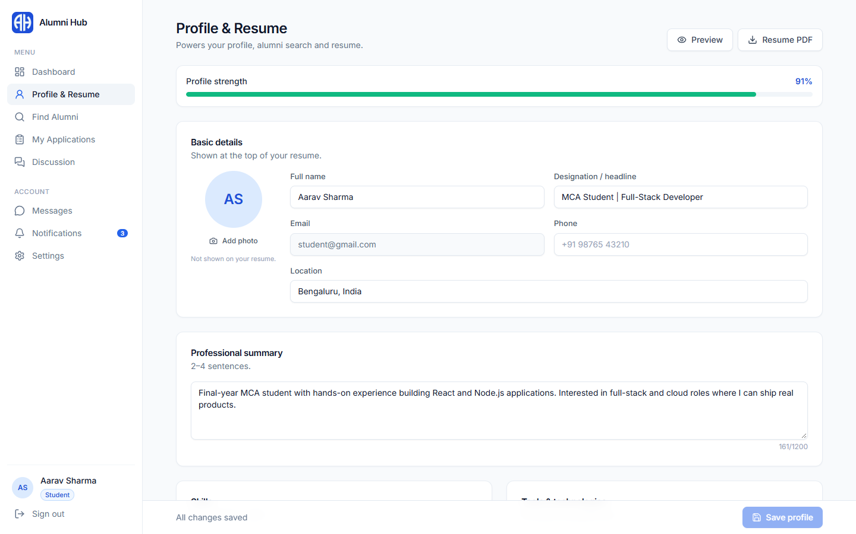
Figure 9.4: Profile builder and resume export
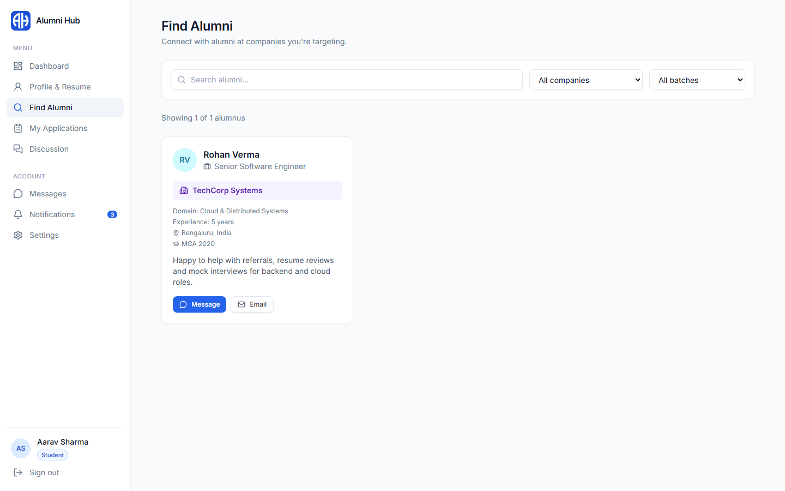
Figure 9.5: Alumni directory for students
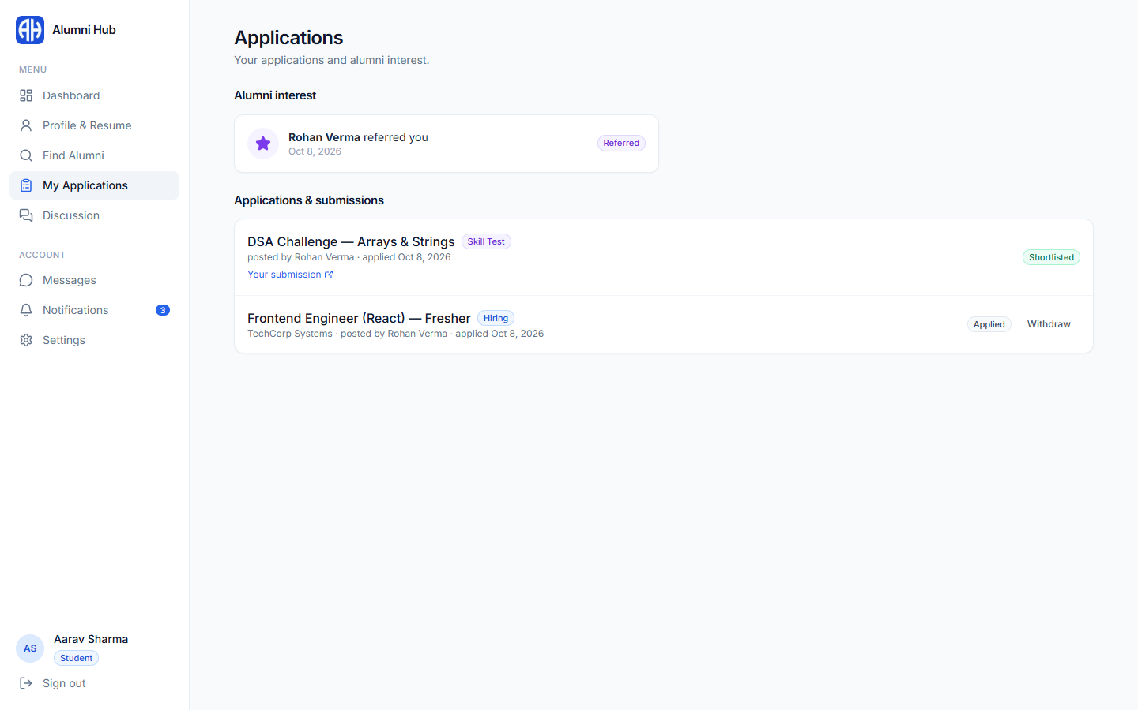
Figure 9.6: Student applications and alumni interest
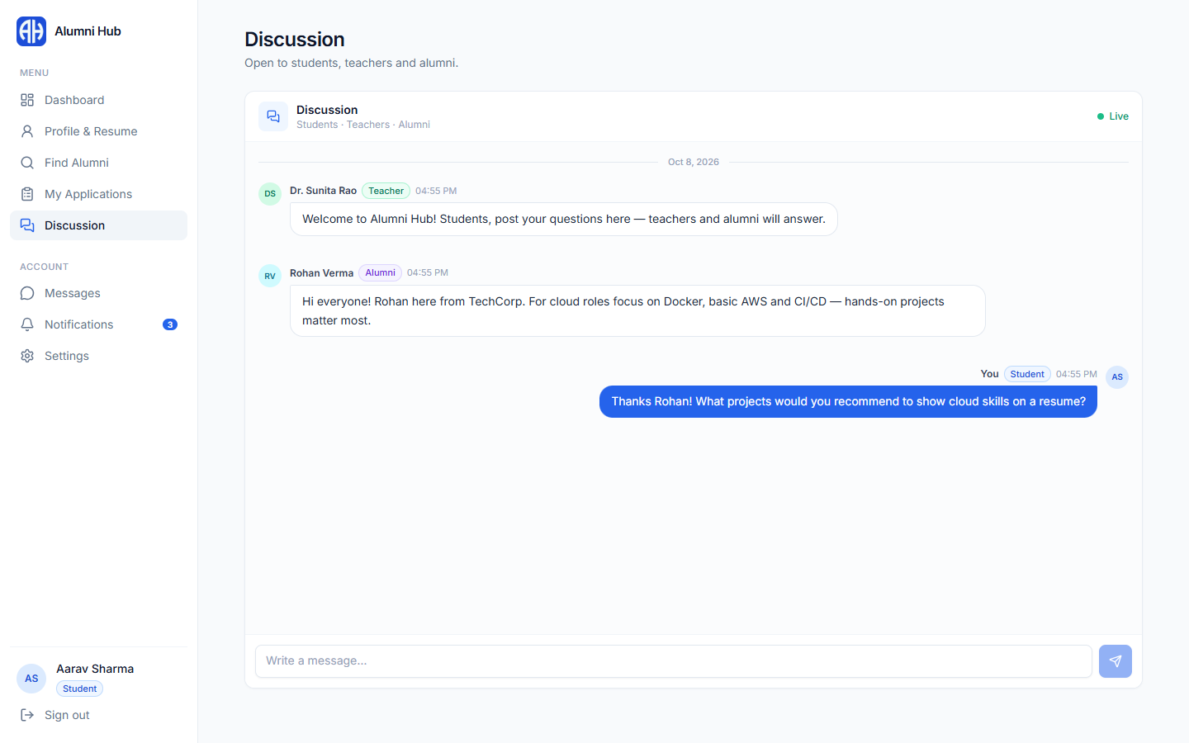
Figure 9.7: Global discussion
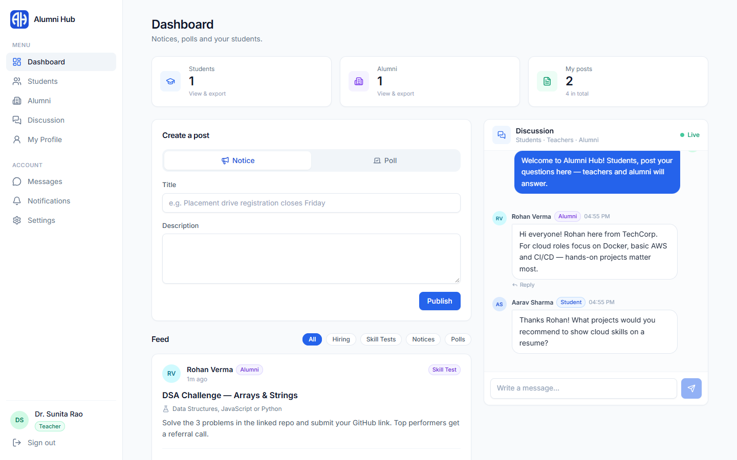
Figure 9.8: Teacher dashboard
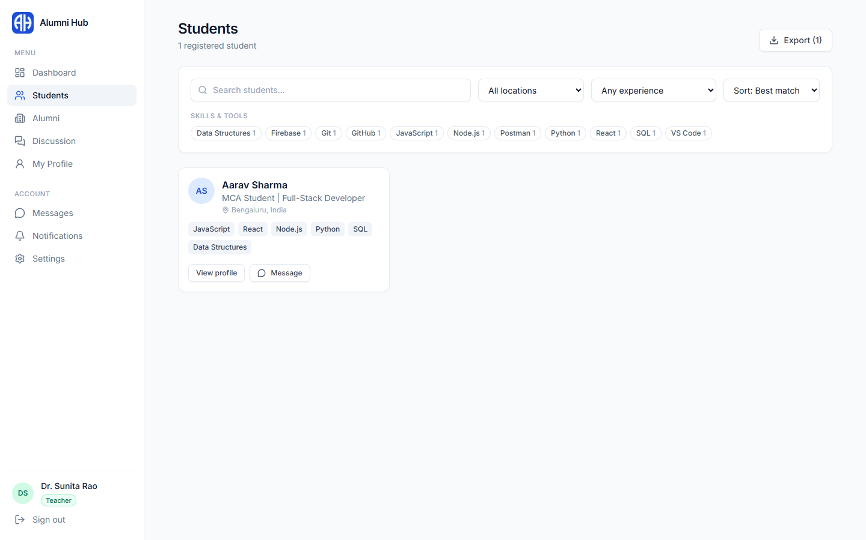
Figure 9.9: Student directory with filters (teacher)
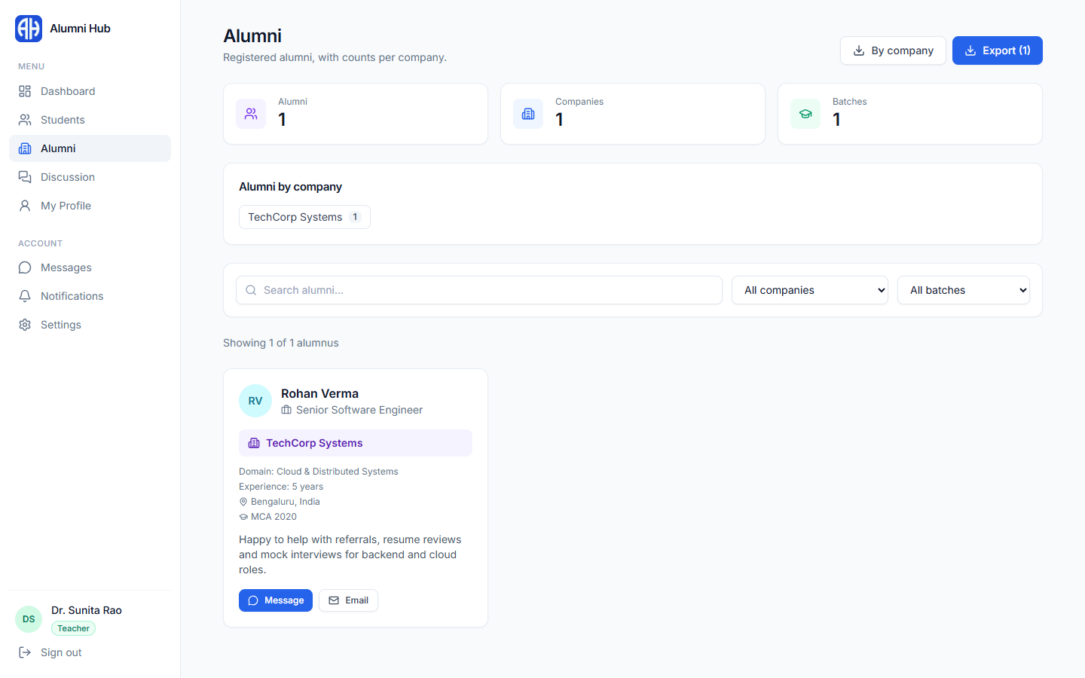
Figure 9.10: Alumni counts by company (teacher)
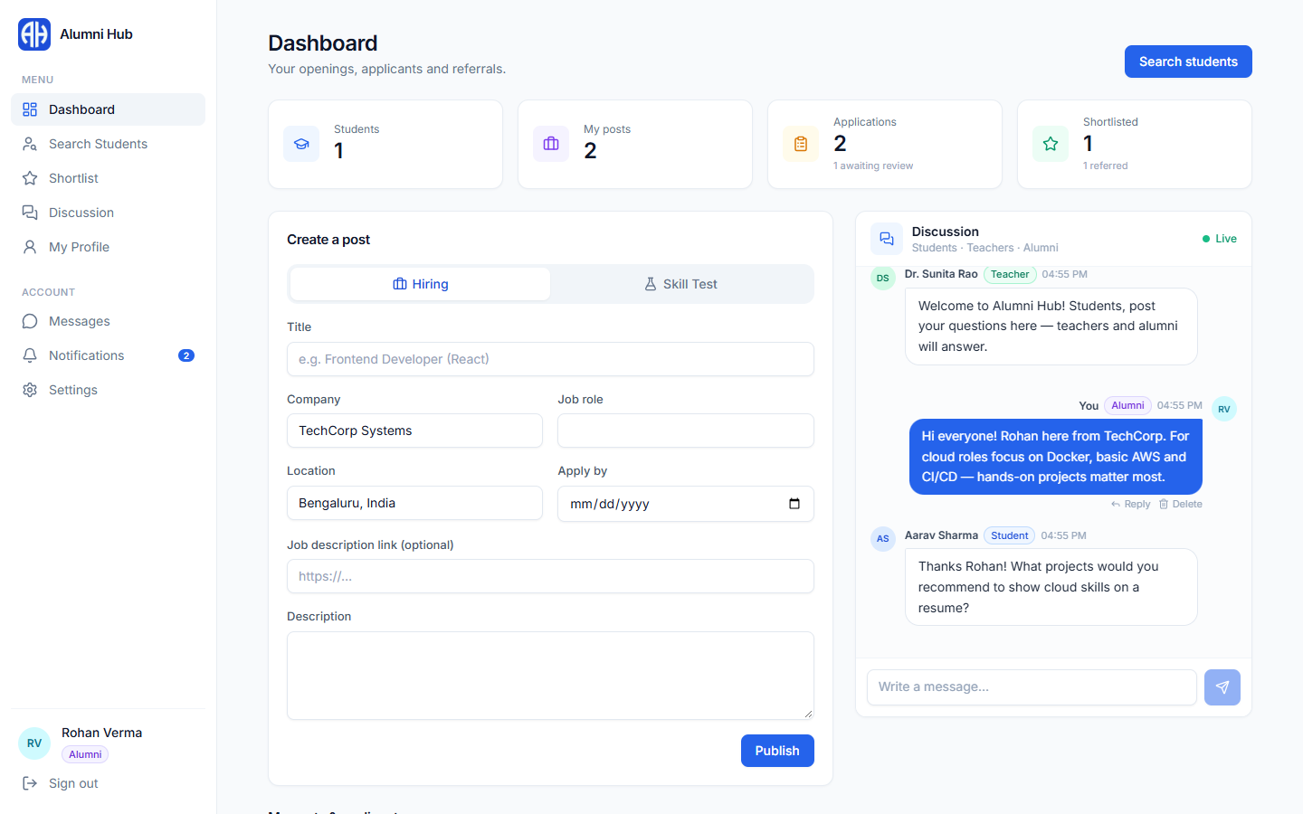
Figure 9.11: Alumni dashboard – create a hiring post or skill test
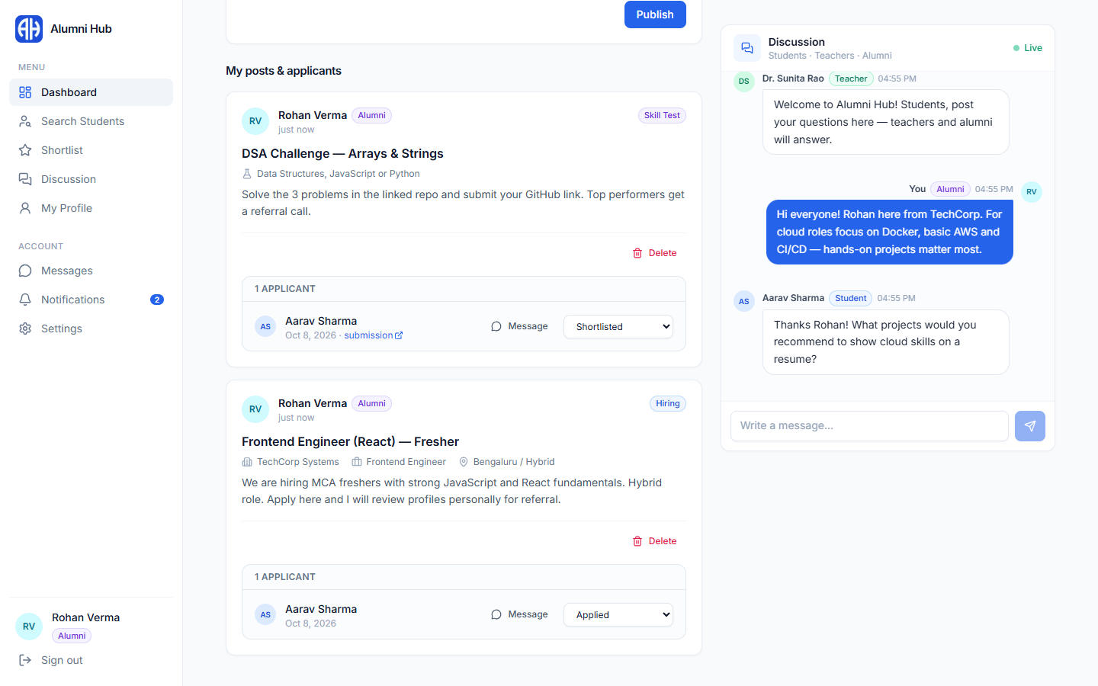
Figure 9.12: Applicants listed under an alumnus's posts
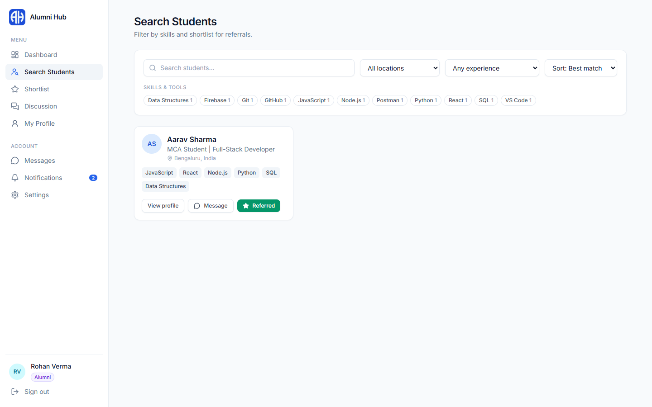
Figure 9.13: Search students (alumni)
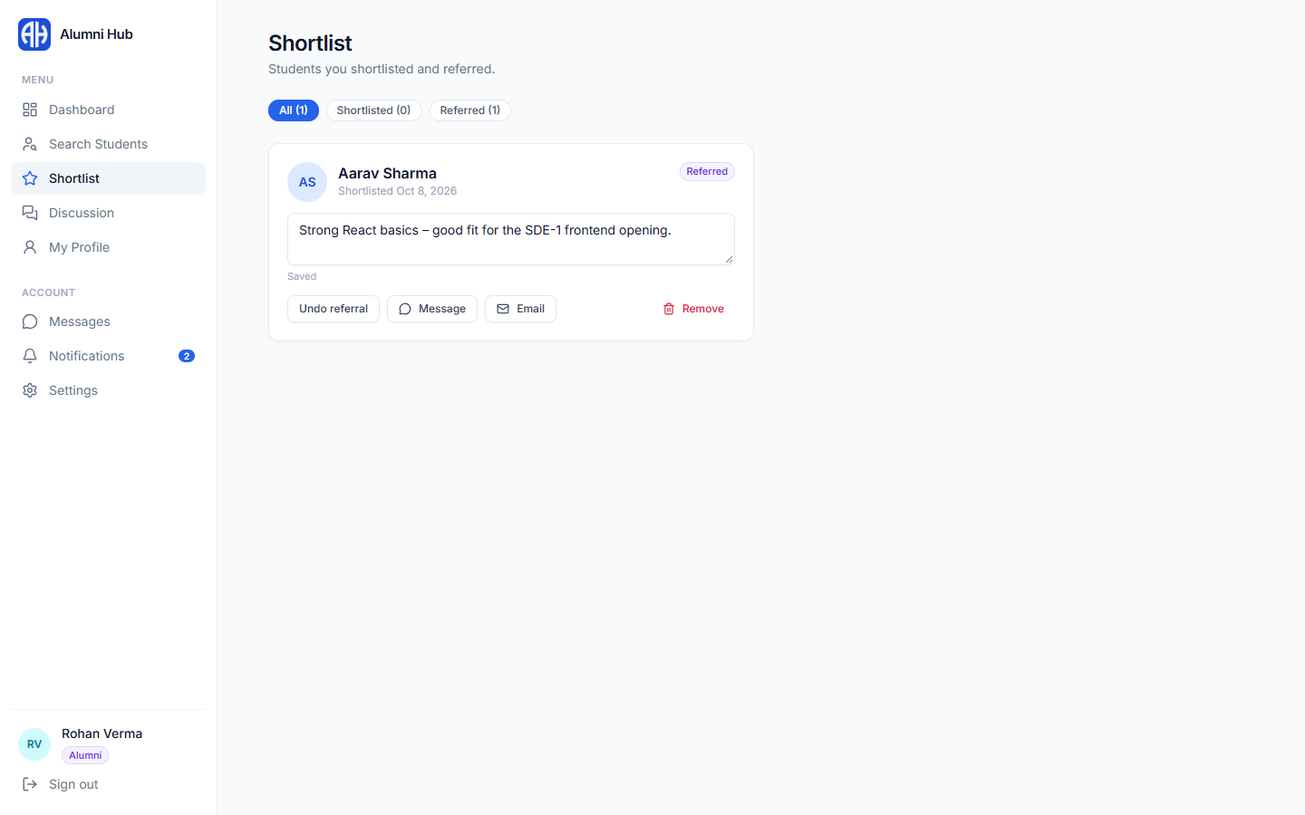
Figure 9.14: Shortlist and referrals (alumni)
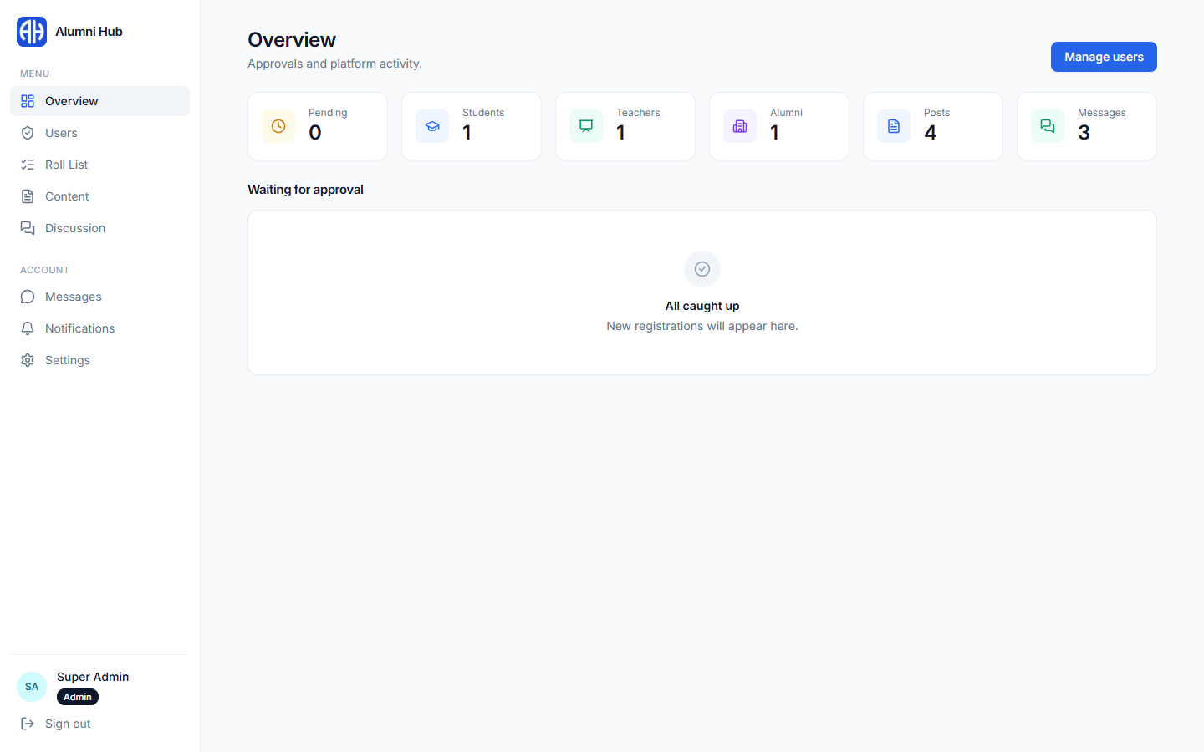
Figure 9.15: Super Admin overview
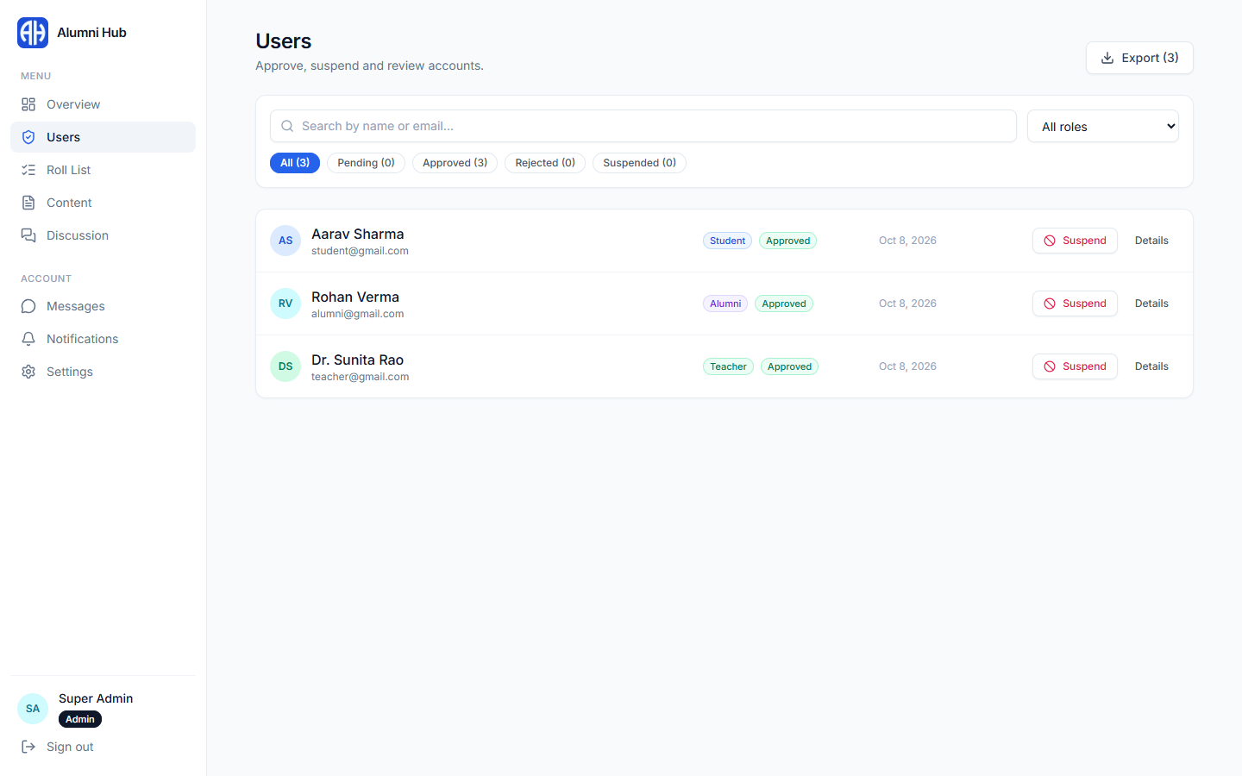
Figure 9.16: Super Admin – users and approvals
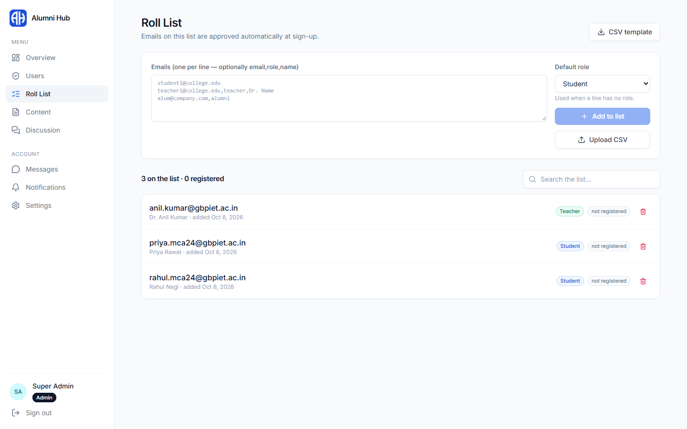
Figure 9.17: Super Admin – roll list
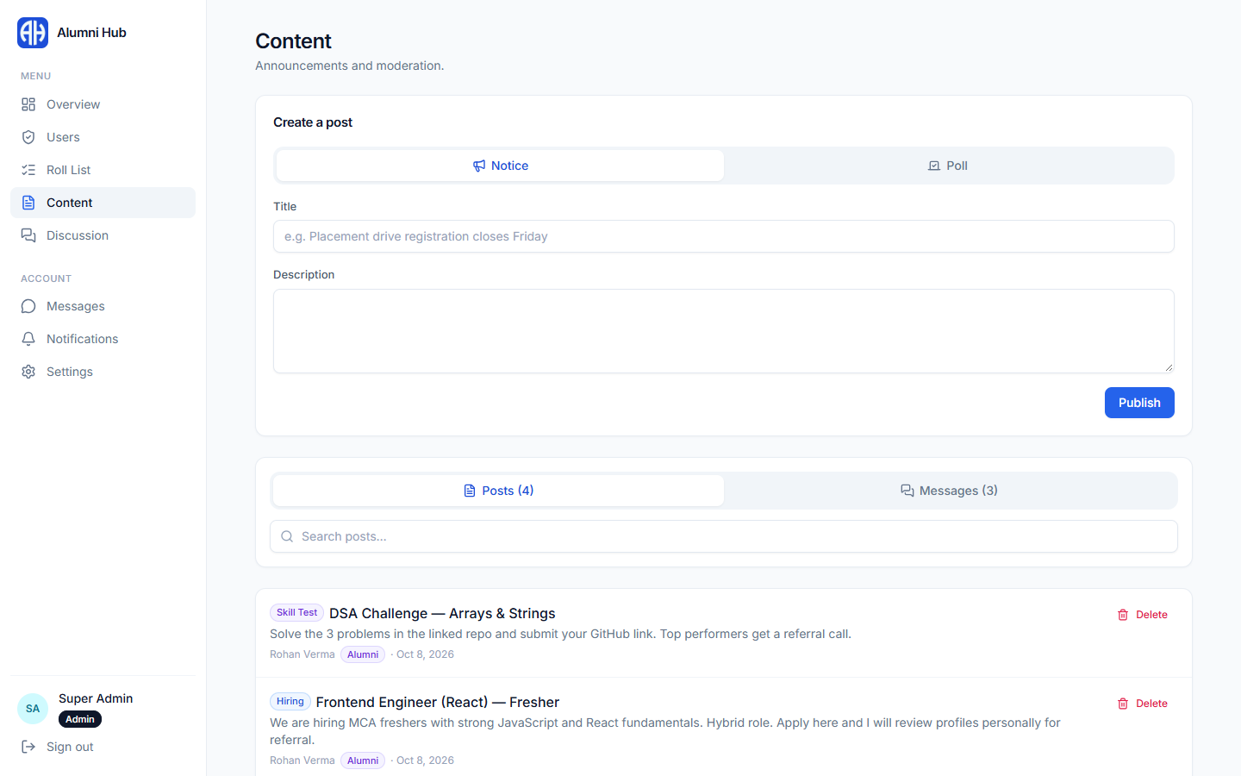
Figure 9.18: Super Admin – content moderation
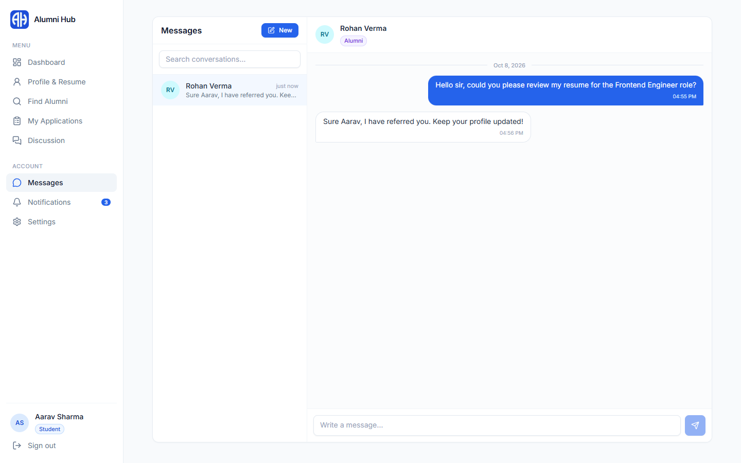
Figure 9.19: Private messages
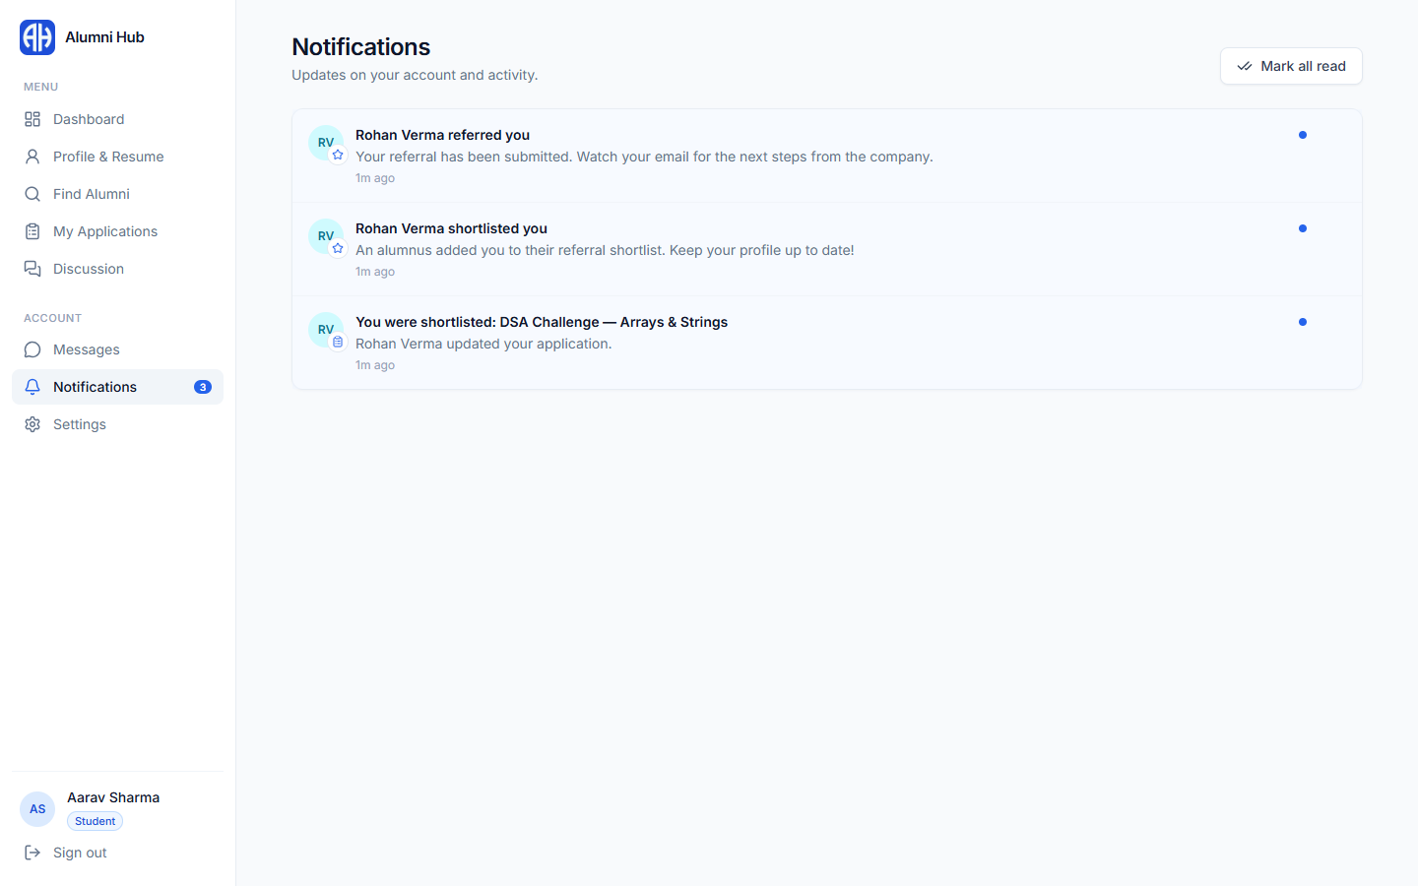
Figure 9.20: Notifications
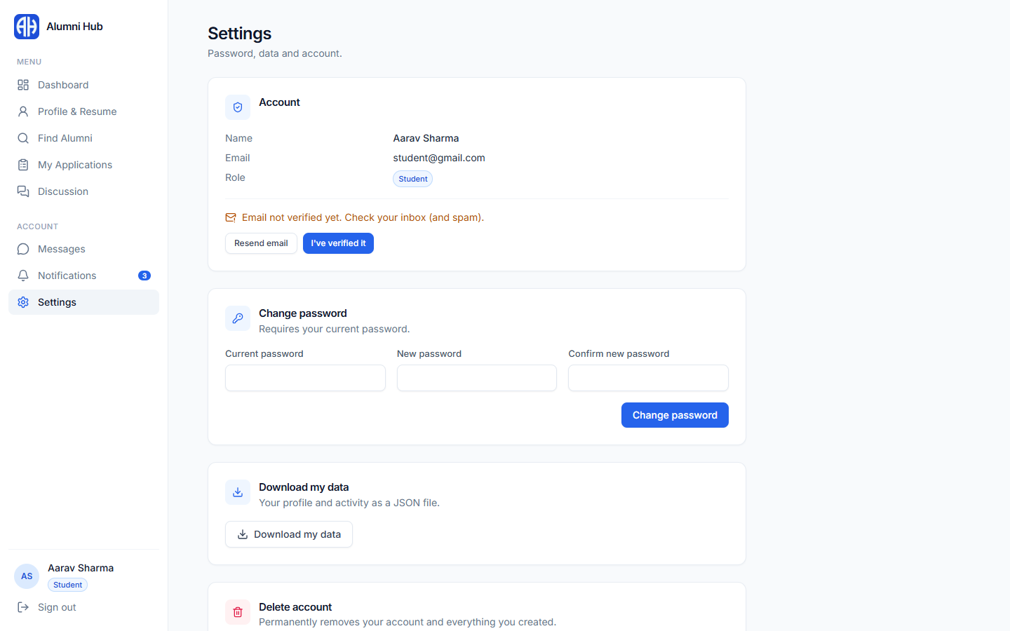
Figure 9.21: Settings – password, data export and account deletion
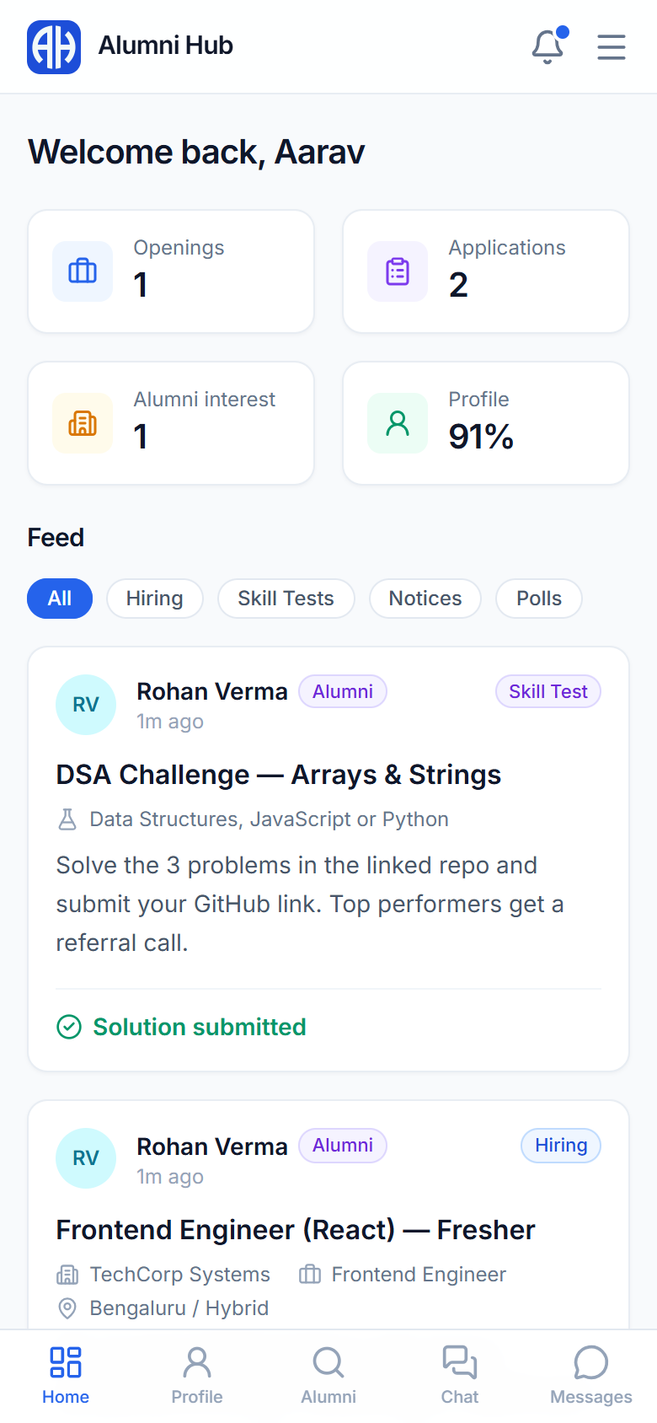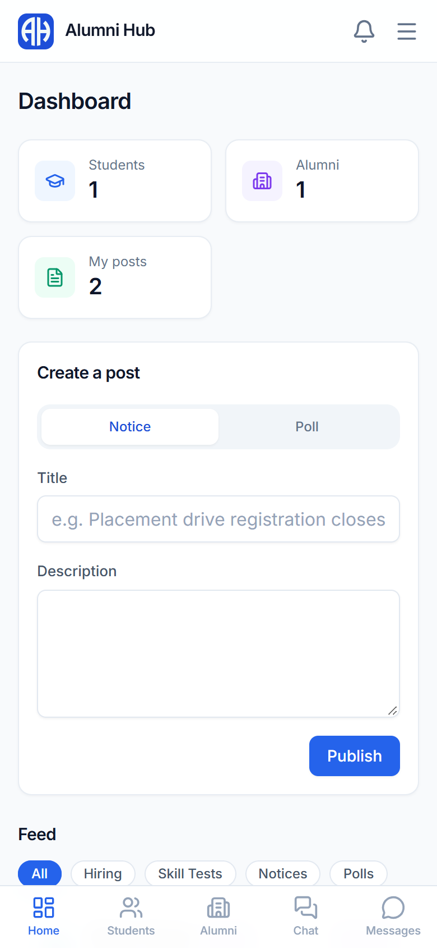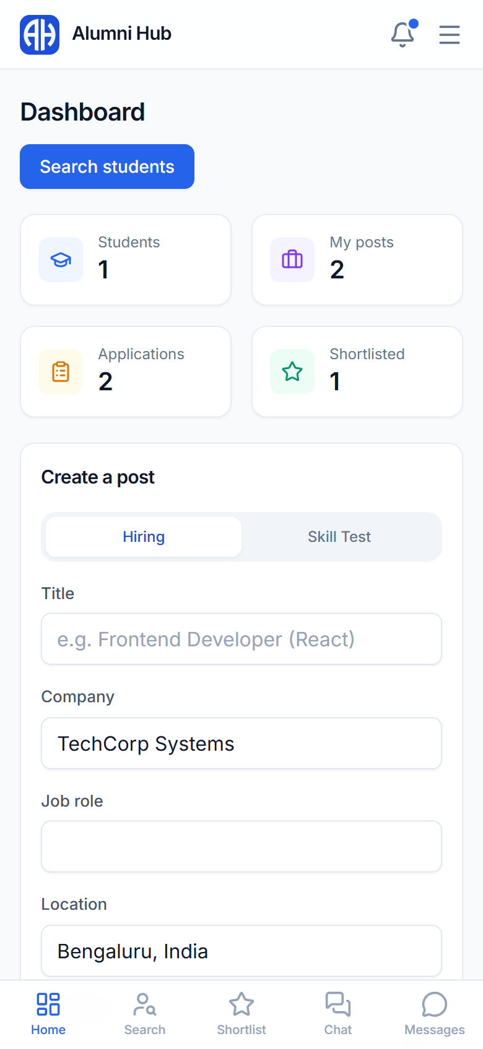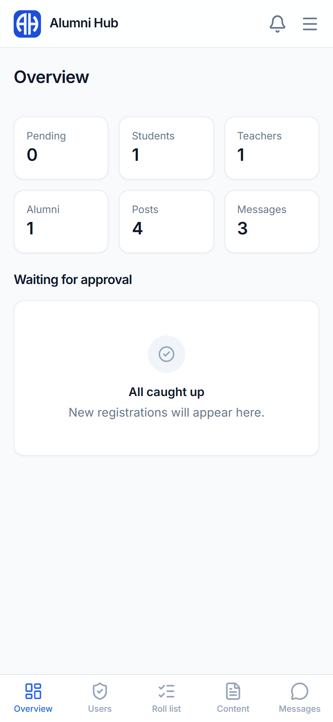
Figure 9.22: Mobile views – student, teacher, alumni and Super Admin

10. Conclusion
Alumni Hub brings students, teachers and alumni of the institute onto one verified platform. Students build a single profile that works as an ATS-friendly resume, teachers publish notices and track students, and alumni share opportunities, review applicants and refer juniors to their companies. A Super Admin verifies every account, so the community stays genuine, and server-side security rules protect every record.
The system has been implemented with React and Firebase, tested with automated browser and security-rule tests, and deployed live on Vercel. This SRS follows the IEEE structure and fully represents the implemented system, making it suitable for academic evaluation and practical submission.

